Shabbos Stories For
Parshas beha’alosocha 5785
Volume 16, Issue 37 18 Sivan 5785/June 14, 2025
Printed L’illuy nishmas Nechama bas R’ Noach, a”h
For a free subscription, please forward your request to keren18@juno.com
Past emails can be found on the website – ShabbosStories.com

The Water Carrier’s Gift
By Rabbi Paysach J Krohn

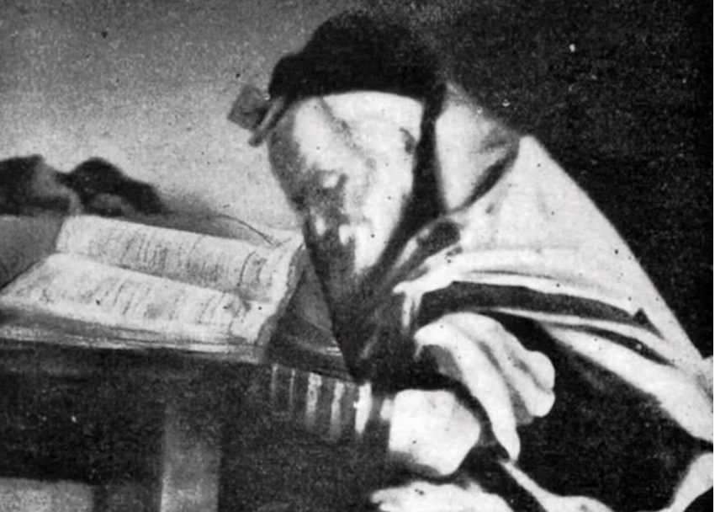
Photo of the Chofetz Chaim towards the end of his life.

In Radin, Poland, lived a pious and kind Jew named Gedalya (Kaplan), the water carrier. Radin was home to the Chofetz Chaim and his renowned yeshiva, which was then instituting the “teg” system—assigning students to eat in different homes on specific days.
When Gedalya heard about it, he respectfully approached the Chofetz Chaim and protested: “It’s bittul Torah. I’ll volunteer to collect the meals so the students can stay in yeshiva and continue learning.”
Moved by Gedalya’s love of Torah, the Chofetz Chaim accepted his offer. Day after day, for years, Gedalya made the rounds in the community, picking up meals to save the students valuable time for learning. When he became seriously ill and passed away young, the Chofetz Chaim personally cared for his widow and two daughters, grateful for all Gedalya had done.

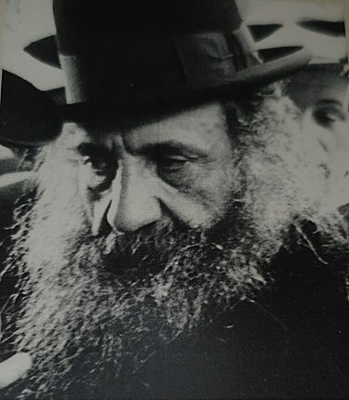
Rabbi Moshe Schneider

Years later, in 1911, that love of Torah bore fruit. The Chofetz Chaim suggested a shidduch between Gedalya’s daughter and a young talmid chochom, R’ Moshe Schneider. R’ Schneider went on to become one of the great Gedolei Torah of the generation, founding a yeshivah in Germany and later in London, famously known as “Schneider’s Yeshivah,” where many future Gedolim learned as talmidim. His wife stood faithfully by his side, having inherited her father’s deep love of Torah.

(Reprinted from the Parshas Bamidbar – Shavuos 5785 email of The Weekly Vort. Excerpted from the ArtScrollbook – “Reflections of the Maggid”)
The Torah Scholar Who
Had Doubts About G-d
From the Desk of Yerachmiel Tilles

A wealthy Jew had an only daughter who was becoming of marriageable age. While there were many promising young Torah scholars in his own town, he desired to have an exceptional Torah scholar as a son-in-law. After much effort in many locations, he indeed found one such young man. The couple married, settled down and were extremely happy. The young man learned in the yeshiva study hall and grew in his learning and Torah knowledge. Everything was going as desired.
Some years passed, and the wealthy father-in-law began noticing small changes in his son-in-law’s conduct and observance of mitzvot (commandments). At first, he tried to dismiss them as insignificant changes, and perhaps his learned son-in-law has reasons to conduct himself in this new manner. “After all, he knows much more than I do, so who am I to question him!”
But as the weeks and months passed, he began noticing that he was taking off much more time from his learning and was seen in the company of others who were known to be completely non-observant. This was a situation that he was no longer able to ignore and pretend all is well.
So, one day, he sat down with his son-in-law and asked him, "What caused this drastic change. Are you perhaps unhappy about something or is something or someone bothering you?"
The son-in-law replied, "I am extremely happy and fortunate. Your daughter is an excellent and kind hearted person. She is the perfect wife, and you are very gracious to us. A man couldn't ask for more.
"But you want to know if everything is perfect, what caused these changes? I began having some questions about G-d's ability to do certain things that our sages stated had happened. I noticed that some of the great commentators also wrote that these things are exaggerations. So, I no longer knew what is real and what is being said as a way of a parable or metaphor.
"Whoever I asked replied either that those are dangerous questions that one is not allowed to ask, or gave me such weak responses and explanations that they themselves admitted weren't complete or satisfactory answers. So now I have my doubts about many things, such as does G-d really care about such minute details, for example, when you wash your hands for bread, does it have to go until the wrist and a drop off makes it invalid or it isn't so important. And therefore, I decided not to do it at all."
The father-in-law was torn with grief. This is the son-in-law that he had handpicked for his wonderful daughter, who is so proper in her observance of every commandment. Is everything lost G-d forbid?
"No! It can't be," he told himself. "I must find a way to correct this." Turning to his son-in-law he said, "My dear son-in-law, you are much more learned than I, and if the great Torah scholars of the town couldn't answer your questions satisfactorily, I for sure don't have the ability. However, I am asking you one thing. Please come with me to a great sage and allow him to answer and clarify everything." Wanting to please his father-in-law, especially as he always has the ability to say that the answer this sage gave was not a convincing or even a good answer, he agreed.

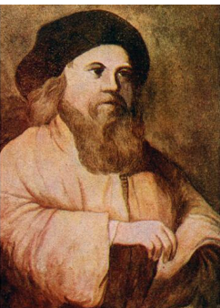
An illustration of the Baal Shem Tov

The father-in-law didn't waste any time, but immediately set out with his sonin-law to see the Baal Shem Tov. They arrived in Mezibuzh on a bright sunny day and the father-in-law poured out his troubled heart to the Baal Shem Tov and pleaded with him that he does whatever is in his ability to bring the sonin-law back to the ways of G-d.
The Baal Shem Tov asked them to join him on a small journey. With the father-in-law sitting on his right and the son-in-law sitting on his left, they left Mezibuzh. Once they were out of the city and on the road in midst of an open field, the Baal Shem Tov turned to the son-in-law and said, "Young man, can it rain now?"
Looking at the clear blue sky, the young man replied, "No, there isn't a cloud in sight."

“And I Say It Can Rain!”
The Baal Shem Tov said, "And I say it can rain!"
Looking up once again, the young man peered in all directions to make sure that he saw correctly and indeed there wasn't a cloud in sight. So, he smugly retorted and said, "It is impossible! No way in the world can it rain here at this very moment."
The Baal Shem Tov smiled and said, "And I say it will rain momentarily!" A few seconds later the heavens opened and a deluge of rain came pouring down. The young man was bewildered. Not only is the rain pouring from a cloudless sky, but the Baal Shem Tov's wagon is remaining completely dry! This was truly miraculous and beyond human comprehension. Being an extremely intelligent person, he realized why the Baal Shem Tov showed him this and didn't try to answer his questions verbally.
Far be it that the Baal Shem Tov was merely showing off to him his miraculous powers. It was much more than that; he had clearly demonstrated, that stories of our sages that are beyond human comprehension, doesn't mean that they never occurred or are not real. There are many happenings that human intellect says one way, but in actuality they happened the opposite way - the way he thought was impossible.

All of His Other Questions Fell Away
Once this question was answered, he realized that all of his other questions and doubts were based on this premise. And therefore, if this was resolved, they all have nothing to stand on. Full of remorse he turned to the Baal Shem Tov and begged him to guide him back to the way of G-d.
Once, during the first year after the passing of the Bal Shem Tov on the second day of the festival of Shavuot, his close followers gathered and sat together, and many of them related a miraculous story of the Baal Shem Tov that they personally were privy to. That night the Baal Shem Tov came to one of his students in a dream and said, "My greatness is not my ability to do miracles, it is my awe of heaven for even the smallest detail of a mitzva.

Reprinted from the Shavuos 5785 email of KabbalaOnline.org, a project of Ascent of Safed in Israel.
The Threat of Shutting
Off the Electricity

Shlomo Horwitz told an amazing story about a 17-year-old yeshivah student named Rafi who was eager and ready to do mitzvot and change the world. Rafi was on a bus in Yerushalayim and having an existential moment, wondering what his purpose in life was. The radio was playing, and the talk-show host interrupted the music to answer an urgent call into the radio station. A young boy called in crying and said, “I’m one of five children. My father died this year, and my mother can’t pay the electric bill. The electric company shut our power, and we’re freezing. We need 1,800 shekalim to have it turned back on.” The radio host got back on and left the number of the station for any donations.

Rafi heard this and immediately decided this was his purpose. He had a mission! He ran off the bus at the next stop, grabbed a pay phone, and called the radio station. He said, “I heard the broadcast, and I’ll raise the money. Tell the family now that everything’s going to be okay!” He opened his wallet, he only had 300 shekalim on him. He went into store after store to raise the money. He told the store owners, “There was something on the radio…” And the owners said, “Yes! We heard it! Are you that guy that’s going to be collecting?” Rafi said, “Yes, that’s me!” Everyone gave what they could. As soon as the money was raised the money, he promptly dropped it off at the station. The host looked at this young boy in awe and said, “Who are you!” Rafi only gave his first name and left.

Ten years later, Rafi was married with two children, struggling financially as an aspiring rabbi. He told his friend that the electric company had shut off his power because he had an outstanding bill of 3,800 shekalim. Another man overheard them chatting and said, “Wait one second. What’s the meter number on your bill?” Rafi happened to have the bill on him and showed the man. The man pulled out his cell phone, walked out, and came back in to tell Rafi it was all settled, and his power would be turned back on in a few hours. Rafi, shocked, asked, “Why would you do that? How?!” The man said, “It’s not me; it’s my aunt Shoshana. She always told me to call her if anyone ever can’t pay their electric bill.”

Rafi got home and called this lady “Aunt Shoshana” to thank her. Aunt Shoshana said, “Ten years ago, I had just lost my husband, and I was widowed with five kids and couldn’t pay my bill. Some angel out of nowhere raised the money in two hours for me!! What an amazing power of the Jewish people. I told myself that I would do the same for people struggling with their electric bills when my financial situation was better. I don’t know anything about the boy that helped me, just that his name was Rafi.” Rafi told her that he was the boy who helped her ten years ago. They both started to cry and wished each other heartfelt blessings because they recognized the beauty of Am Yisrael, who always look out for each other and are eager to be inspired to serve Hashem.

Reprinted from the Parashat Bamidbar/Shabuot 5785 email of Jack E. Rahmey based on the Torah teachings of Rabbi Amram Sananes.

The Steipler Gaon’s Letter
By Yoni Schwartz

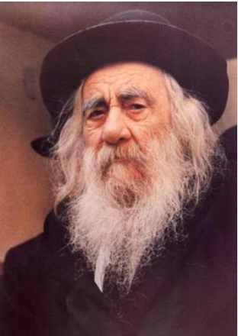

The Steipler Gaon, ZT”L, was once going through a tough time financially. He ended up getting in touch with and working alongside Rabbi Dardack from Cleveland, who offered to help sell his seforim in America. When Rabbi Dardack received the first shipment of seforim, he began learning them and wrote down any questions he had. After a few months, when the seforim were sold and he was sending back the money to the Steipler, he included all his questions on the seforim. When Rabbi Dardack received the next shipment, he also received the answers to all his questions. This cycle went on for years.
Later in life, the Steipler stopped selling seforim and responding to letters due to his old age. Nevertheless, he always pushed himself to respond to Rabbi Dardack. However, since he didn’t have much money, he would bring his letters to the house of Mr. Dardack, Rabbi Dardack’s father, who lived nearby and would then send them to his son.
One time, he brought over a letter, returned shortly after asking for it back, and then came back again with a newly written one. Mr. Dardack asked if there was a mistake in the first letter. The Steipler responded, “No, I didn’t change a word.”
Curious, Mr. Dardack then asked why he rewrote the letter. The Steipler responded, “Normally, I don’t write letters anymore. However, I don’t want your son to think that I don’t care to respond now that I don’t need his help anymore. So, I pushed myself to write the first letter, despite it being difficult. However, I wrote it in a rush, like it was a burden. I wanted to rewrite it properly, with hakaras hatov - not because I must respond to him, but because I want to.”

Reprinted from the Parshas Bamidbar/Shavuos 5785 email of Torah Sweets.

Again, and Again
By Rabbi Yitzchok Hisiger

R’ Eliezer Yosef Lederberg was a storekeeper who lived in Batei Varsha in Yerushalayim; he used every spare moment to learn Torah. R’ Eliezer Yosef was diagnosed with a disease that affected his eyes and was informed that he would have to undergo surgery, which would likely cause him much discomfort afterward and possibly even render him blind.
“How long can I wait until I undergo the surgery?” asked R’ Eliezer Yosef. They told him that he can wait six months, but not longer than that. R’ Eliezer Yosef realized that once the operation was performed, it was probable that he’d never be able to look into a Gemara ever again. If that was true, he had work to do.
For the next half a year, he spent every waking moment of every day focused on one thing: learning two masechtos by heart. He learned Rosh Hashanah and Beitzah over and over, day in and day out. The only thing that consumed him was mastering those masechtos.
R’ Eliezer Yosef prepared himself for the challenge that he might be forced to face on the road ahead. On the day of the operation, his family wept while saying Tehillim, hoping and davening for a positive outcome. As he was about to be brought into the operating room, he gazed at his family, knowing that this might be the last time he would be able to see them.
He thought of all the moments he had wasted during his lifetime. But now he had achieved something remarkable. He had mastered those two masechtos. When he woke up after the surgery, his eyes were bandaged. They wouldn’t know for a few days if the operation was a success and whether he’d ever be able to see again.
Finally, the day arrived. Thick apprehension filled the air. R’ Eliezer Yosef took off the bandages and couldn’t hold himself back from crying. He was able to see! For the rest of his life, wherever he went, he reviewed the masechtos that he had mastered before his operation.

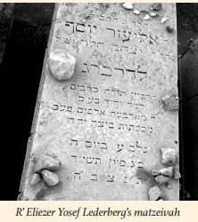

After his petirah in 1954, his children read his will. In it, he instructed them to write on his matzeivah that he had learned Rosh Hashanah and Beitzah over 4,000 times. He explained his reasoning: “Perhaps one day someone will read this and accept upon themselves to do the same.”
When I heard this story, I wondered if it was true. Then a friend of mine told me that he had gone to Har HaMenuchos himself to find the kever. There, he saw that the words were indeed inscribed on R’ Eliezer Yosef’s matzeivah.

Reprinted from the Bamidbar/Shavuos 5785 edition of At the ArtScroll Shabbos Table. Excerpted from the ArtScroll book – “Moments of Greatness.”

The Legacy of Rav
Elya Meir Bloch, zt”l

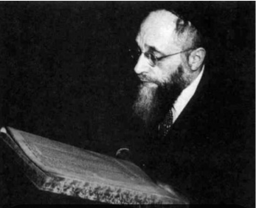

When Rav Elya Meir heard of a departure from the strict standards of truth and honesty, he became outraged at the resulting chillul Hashem. At one Telshe alumni convention, when the former talmidim expected to hear a profound and inspiring shmuess, Rav Elya Meir began with forceful words, "Men tor nisht zein a ganov (One is not allowed to be a thief)." In an agitated voice, he told the assembled that on a recent trip, he had been short of cash, and had asked an acquaintance to lend him $100 until the next day.
When he detected reluctance on the man's part, Rav Elya Meir asked incredulously, "I said I will bring you the money tomorrow. Don't you trust me?" The man, who knew Rav Elya Meir quite well, shamefully replied,
"It's not that I don't trust you, Rabbi. It's just that I've had a bad experience." Rav Elya Meir had been beside himself, as he realized that another talmid chochom had borrowed money from this man and had not repaid the debt. He continued speaking in distress to his talmidim,
"Do you understand what matters have come to? A businessman does not trust a RoshYeshiva with $100 until the next day because of a 'bad experience'! You came here expecting to hear some deep thoughts. You may go back home and say that you came to Cleveland to hear the Telshe Rosh Yeshiva say, 'Men tor nisht zein a ganov!'"

Reprinted from the Parshas Emor 5785 email of Chayeinu Weekly.

Crying Over a Brocha
for Having Children


Rav Yaakov Bender

A young man once approached Rav Yaakov Bender and told him a story that took place with his wife and Rav Bender’s mother, Rebbetzin Bender. Shortly after their Chasunah, this man’s wife had some extra time, and in order to do something good with her time, she went to help Rebbetzin Bender, who was getting a little older.
Rebbetzin Bender appreciated this young woman’s wonderful Middos, and her loving company. One day, as she was getting ready to leave, Rebbetzin Bender gave her a Brachah that she should be Zocheh to have children very quickly.
Instead of heading home, the young woman went straight to her parents’ house. When she got there, she started crying uncontrollably. Her mother didn’t know what was wrong, as she was usually a very happy person. Finally, when she was able to speak, she said, “The Rebbetzin gave me a Brachah to have children quickly!”
Very puzzled by this, her mother asked her, “That is such a beautiful Brachah! Why are you crying because of that?”
The young woman replied, “It is because of my older sister who has been married for a few years already, and still doesn’t have children! Now I have a Brachah, how could I have a child first?”
Her mother was shocked, and said to her, “It looks like it is now up to you. You must Daven for her!” Resolute, the young woman took a deep breath, picked up her Tehilim, and started Davening like she never had before. She continued doing this and kept thinking, “The Rebbetzin gave me a Brachah, but how could I see my sister in pain?”
Not too long later, maybe just a few weeks, at different times on the same night, both sisters came to visit their parents, telling them the news, that they were going to have a baby!”

Reprinted from the Parshas Bamidbar 5785 email of Rabbi Yehuda Winzelberg’s Torah U’Tefillah.

The Rebbe’s Favoritism
for the Rich Man



Rav Scheinbaum shared a story about a man who was once waiting in line to enter the office of the Yismach Yisroel, the Alexander Rebbe, zt”l. While he was waiting, he noticed something that struck him as unusual. The poor people entered the Rebbe’s office, handed him a piece of paper on which they had written their requests from him, and they came out of his office almost immediately. It was so quick. They would donate a couple of pennies for Tzedakah, get a quick Brachah, and then it was on to the next in line.
However, the wealthy people would enter the Rebbe’s room and spend quite some time engrossed in conversation with the Rebbe. This man was confused and he became enraged. True, it is the way of the world that the wealthy get preferential treatment, but he would never have expected this to occur with the holy Alexander Rebbe! This was something that could be expected in a bank when someone with a large deposit to make enters, and the entire staff, from the president down to the tellers, all come out to greet him. He could not keep his incredulity to himself.
When he entered the Rebbe’s room, he immediately shared his feelings. The Rebbe understood the man’s consternation, and with a friendly smile and extreme patience, he explained to the simple man why the wealthy people took much longer for their requests to be discussed.
The Rebbe said, “Believe me, my time is very valuable. I have much to achieve with the short time that I have for myself. I must learn and maintain everything I am devoted to, but I give a certain amount of time to listen to the requests of Yiden in need, and I attempt to address their concerns and offer them Brachos.
“When a poor person enters my office, I immediately know what is on his mind. I know what he has and how much he is missing, and I attempt to offer him my Brachah. When a wealthy man enters my room, he is usually smiling and feeling good about himself, as if he does not have a care in the world, and I begin to investigate the real reason for why he is seeking my Brachah.
“I ask him, ‘How is everything?’ to which he replies, ‘Wonderful, could not be better.’
“‘Truly?’ I ask. Is there nothing that is bothering you? Is your family well? How about your business? Are you faring well with your partner?’ With each question, another layer of the false front of happiness is removed, until he exclaims that his business is going down, his partner has deceived him, and that he and his wife are not on the same page concerning how to raise their children, which is causing their children have serious issues.
“After some time, I have been able to reveal the real reason for his visit. You must realize that it takes time to reveal that the wealthy man is himself quite poor.”
The man understood and learned that everyone has concerns to deal with, and their outward appearance is not a good way to determine what is really occurring with them. The reality of their situation will actually be nothing to be jealous about!

Reprinted from the Parshas Bamidbar 5785 email of Rabbi Yehuda Winzelberg’s Torah U’Tefillah.

